Project Report: Telco Customer Retention Analysis
Analyst: Susendran K
Tools Used: Python (Pandas, Seaborn), Microsoft Excel, Power BI
Data Source: IBM Telco Customer Churn (Kaggle)

1. Project Objective
The goal of this project was to analyse customer behaviour for a telecommunications company experiencing a 26.58% churn rate. The analysis aims to identify the root causes of customer attrition and provide data-driven recommendations to stabilize Monthly Recurring Revenue (MRR).
2. Data Preprocessing (Python)
Before analysis, the data was "audited" for quality issues:
- Data Cleaning: Identified that the Total Charges column was stored as an object dtype due to empty spaces. Used pd.to_numeric () to convert it to float dtype.
- Missing Values: Removed 11 rows with null values in Total Charges to maintain data integrity.
- Exploratory Stats: Determined that churned customers paid a significantly higher average monthly fee ($74.40) compared to retained customers ($61.30).
3. Key Findings & Insights
Through a combination of Excel Pivot Tables and Python visualizations, three major drivers of churn were identified:
- High-Risk Contracts: Customers on Month-to-Month contracts represent the highest risk, especially during their first 6 months of tenure.
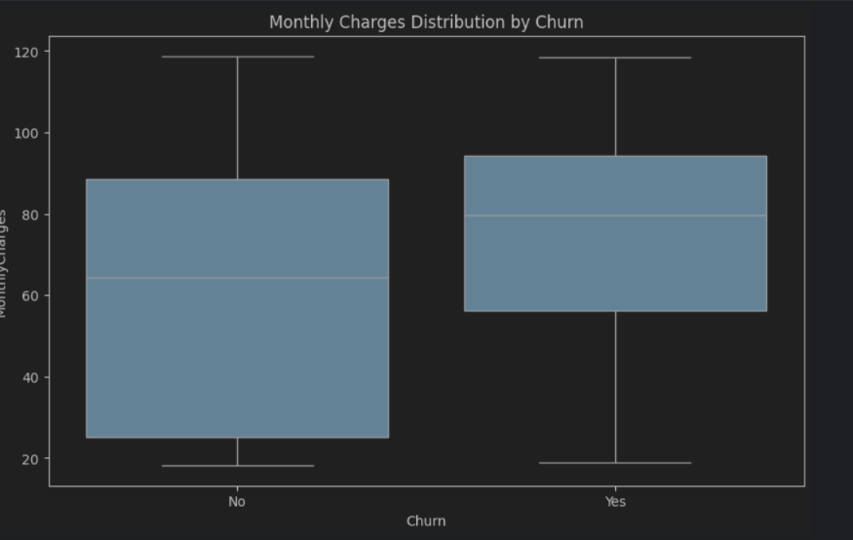

- The Fiber Optic Paradox: While Fiber Optic is the fastest service, it has a churn rate of 41.89%. This is significantly higher than DSL, likely due to the high price point (Median $80).
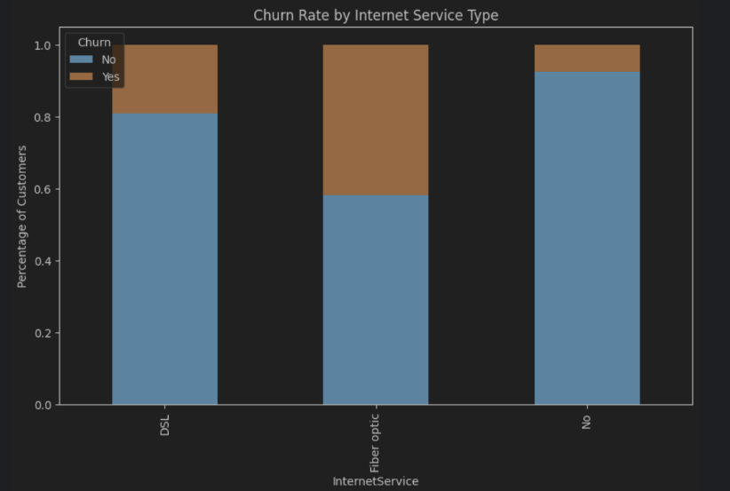
- The Tech Support Gap: A critical finding was that 63% of internet users did not have Technical Support. There is a direct correlation between the absence of support and the decision to churn.
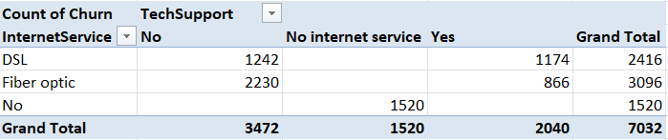
4. Dashboard Overview (Power BI)
I developed an interactive dashboard to allow stakeholders to drill down into customer segments.
- KPIs: Displays Churn Rate, Revenue lost to churn, Revenue at risk, Average Customer tenure, and Potential revenue saved.
- Service Analysis: Visualizes the impact of Internet Service types and Contract terms on retention.
- Segment Filtering: Includes slicers for Payment Method and Tech Support to identify specific "at-risk" groups.
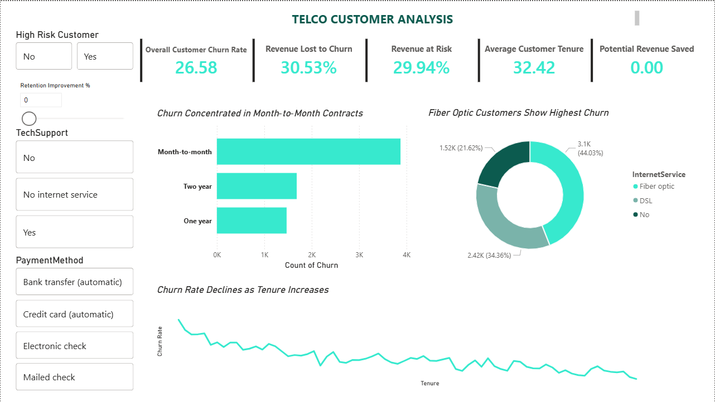
5. Final Recommendations
Based on the data, the following strategic actions are recommended:
- Contract Migration: Launch a marketing campaign to transition Month-to-Month customers to 1-year contracts using a small monthly discount.
- Support Bundling: Include "Premium Tech Support" as a standard feature for Fiber Optic plans to increase perceived value.
- The "6-Month Milestone": Implement a proactive customer success outreach for new users reaching their 3rd and 6th months, as these are peak churn windows.

6. Conclusion
This project demonstrates that churn is not just a pricing issue but a combination of contract flexibility and service support. By focusing on the "High-Risk" segment identified in the dashboard, the company can prioritize retention efforts where they will have the highest financial impact.

